**Ayesha Zubair**

**52916**

**Lab 8**

**Task 1:**

START:

INP

STA NUM

INP

CMA

INC

ADD NUM

OUT

HALT

NUM: .data 1 0

**Output**

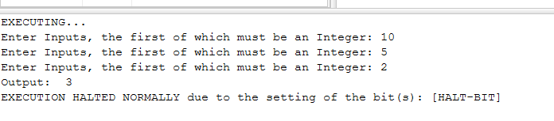

**Task 2:**

START:

ADD NUM1

CMA

INC

ADD NUM2

OUT

HALT

NUM1: .data 1 3

NUM2: .data 1 8

**Output:**

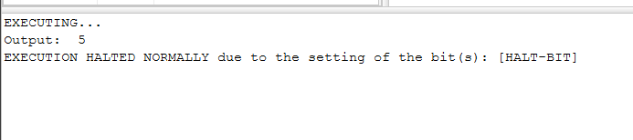

**Task 3:**

START:

INP

STA NUM

INP

CMA

INC

ADD NUM

STA RESULT

OUT

HALT

NUM: .data 1 0

RESULT:.data 1 0

**Output:**

